NAME: GRADE:



Formal Assessment Task 1
ACT | FAT | TO MARKS | SASAMS | ACHIEVEMENT
1 | Listening and Speaking | 20 | 10
2 | Reading & Viewing | 20 | 20
3 | Reading Comprehension | 20 | 20
4 | Language Structure | 15 | 40
5 | Writing and Presenting | 25 | 40
 | TOTAL | 100 | 70

FORMAL ASSESSMENT TASK 1
ACTIVITY 1: LISTENING AND SPEAKING
___________________________________________________________________

DATE:

Activity
Listen to and discuss a story and do a listening comprehension.

Form of assessment
Oral questioning after observation.

Assessment Tool:
Rubric

Recording and Reporting

Criteria | Marks | Learner’s Achievement
Participation in class discussion and drama activity. | 10
Ability to express self orally | 10
TOTAL | 20

Comment

_________________________________________________________________________________________________________________________________________________________________________________________________________
Rubric to assess listening and speaking
Listening and speaking
20 marks
 | 8-10 | 6-7 | 4-5 | 1-3
Participation in class discussion and drama activity | Skilfully sustains a conversation; listens to others with respect; takes turns; justifies own point of view; shows excellent understanding of the topic. Answers all questions correctly. | Takes part in the discussion; listens to others with respect; takes a point of view and sometimes justifies it; takes turns; shows understanding of the topic. Answers most questions correctly. | Takes part in the discussion adequately; able to listen and follow; few interruptions of others; defends viewpoint adequately; shows some understanding of the topic. Answers a few questions. | Takes little or no part in the discussion; does not listen to others; or frequently interrupts; does not follow the thread of the conversation; does not take a viewpoint. Cannot answer questions at all.
 | 8-10 | 6-7 | 4-5 | 1-3
Ability to express self orally | Expresses her/himself very well. Able to say what he/she wants to say clearly and easily with few or no mistakes. | Expresses him/herself well. Able to say what he/she wants to say clearly and fairly easily, but with some mistakes. | Expresses him/herself with some difficulty. Struggles to say what he/she wants to say and makes many mistakes. | Struggles to express him/herself orally. Makes many mistakes. Difficult to understand. Says only one or two words.

What to do
1. Listen to your teacher reading a Modern Fairytale “The Tear thief”
2. Discuss the story and answer questions orally.
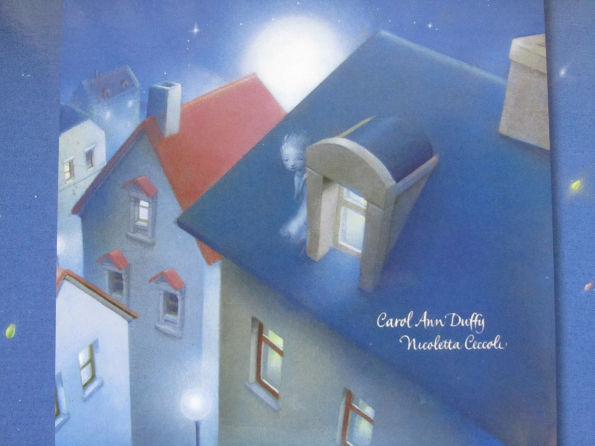
3. Speaking and listening / drama activity. Re-enact the interactions between the Tear Thief and the little girl

FORMAL ASSESSMENT TASK 1
ACTIVITY 2: READING AND VIEWING
___________________________________________________________________
DATE:

Activity
Read the dialogue between the Tear Thief and the little girl.

Form of assessment
Oral: Read out loud.

Assessment Tool:
Rubric

Recording and Reporting
Criteria | Marks | Learner’s Achievement
Demonstrates use of tone and inflection | 10
Convey meaning to the audience | 10
Use of voice and mastery of reading skills | 10
Use of eye / audience contact | 10
Responses to questions shows critical interpretation of the text | 10
Attitude and opinion shows critical interpretation of the text | 10
Prepared and confident | 10
TOTAL | 70÷70=1x20

Comment

_________________________________________________________________________________________________________________________________________________________________________________________________________
Rubric to assess prepared reading
Criteria | LEVEL 7 | LEVEL 6 | LEVEL 5 | LEVEL 4 | LEVEL 3 | LEVEL 2 | LEVEL 1
MARKS  20 | 10 – 8 | 7 | 6 | 5 | 4 | 3 | 2 – 0
Demonstrates use of tone and inflection | Reads expressively and creates atmosphere. Conveys feelings exceptionally well | Reads with very good expression and attempts made to convey feelings or atmosphere | Reads with good expression and attempts made to convey feelings or atmosphere | Makes an attempt to read with expression | Reads, but with limited expression | Meaning can be followed but not expression | Too poor to be expressive. Meaning lost
Convey meaning to the audience | Audience reaction shows a high degree of interest | Audience reaction largely showing interest and involvement | Audience reaction shows interest and involvement | Most members of the audience show interest | Some members of the audience show interest | Fails to capture the attention of most of the audience | Almost no interest from audience.
Use of voice and mastery of reading skills | Fluent, very entertaining reading  Excellent voice projection and diction which enhances meaning | Fluent reading  Very good voice projection and diction which enhances meaning | Reading fluency in a monotone  Good voice projection and diction which enhances meaning | Reads reasonably fluently  Reading is clear and audible and diction enhances meaning | Reads with limited fluency  Reading is audible and pronunciation does not affect meaning | Reading not fluent  Reading not always audible and many words are mispronounced | Halted reading  Poor pronunciation and poor delivery make the delivery almost incomprehensible
Use of eye / audience contact | Altogether appropriate eye-contact | Very good eye-contact | Good eye-contact | Successful efforts to make eye-contact | Eye-contact adequate | Unsuccessful attempts at making eye-contact | Almost no eye-contact
Responses to questions shows critical interpretation of the text | Handles questions with total confidence, ease and sensitivity to the text | Handles questions with confidence, ease and sensitivity to the text | Handles questions and responds sensibly with minor lapses | Handles questions and responds sensibly with lapses | Understand questions and can answer some of the questions | Understands questions and provides flawed answers | Is mostly unable to understand or respond to questions
Attitude and opinion shows critical interpretation of the text | Attitude and opinion confidently sustained and justified | Opinion well sustained and justified | Able to sustain opinion and justify it | Opinion reasonably confidently supported | Opinion sometimes adequately supported | Very hesitant to express an opinion | Unable to substantiate opinions
Prepared and confident | Reading is exceptionally well prepared and confident | Reader well prepared and reads with confidence | Reader prepared and reads with confidence | Reader is adequately familiar with the text – has made an effort to prepare | Limited amount of preparation. Reads with moderate confidence | Reader has not prepared the text. Obviously nervous | No evidence of preparation. Very nervous and demonstrates a lack of commitment
TOTALS | 70÷70=1x20

What to do
1. Prepare the dialogue at home. Pay attention to reading skills.
TEXT: A DIALOGUE
Narrator: The Tear Thief could tell that just one of these tears was worth a hundred cried over spilt milk or a thousand crocodile tears. She reached out her pale hand to pluck one from the girl's cheek. Just then the girl wiped her eyes with her sleeve and looked sadly into a puddle. The Tear Thief's mischievous face stared up at her.
The girl (squealing): Eeek!
Narrator: She turned round to look behind herself. There was nobody there.
The girl looked at the puddle again. Sure enough, there was the reflection of the Tear Thief in the water.
The girl (puzzled): Who are you?
The Tear Thief (calmly): I am the Tear Thief.
Narrator: The girl knelt down by the puddle and stared hard at the Tear Thief's reflection.
The girl: How old are you?
The Tear Thief (mysteriously): As old as joy and sorrow.
The girl: Where do you live?
The Tear Thief: In every place where children cry.
The girl (unbelieving): Were you going to steal my tears?
The Tear Thief: Yes. Your tears are the most precious of all.
They are worth more than diamonds.


FORMAL ASSESSMENT TASK 1
ACTIVITY 3: READING COMPREHENSION
___________________________________________________________________
DATE:

Activity
Answer questions based on a modern fairytale: The Tear Thief.

Form of assessment
Reading Comprehension.

Assessment Tool:
Memorandum

Recording and Reporting

Criteria | Marks | Learner’s Achievement
Reflect on reading material. Answer questions based on the story. | 20

Comment

_________________________________________________________________________________________________________________________________________________________________________________________________________

What to do: Use the following information to help you.
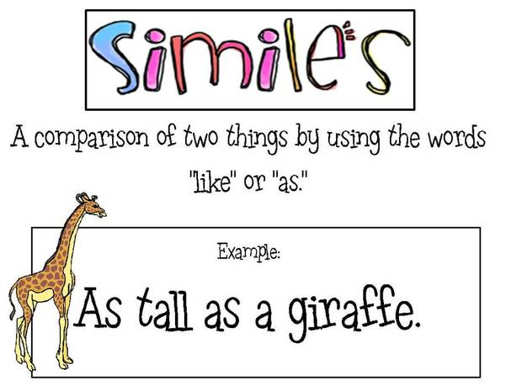
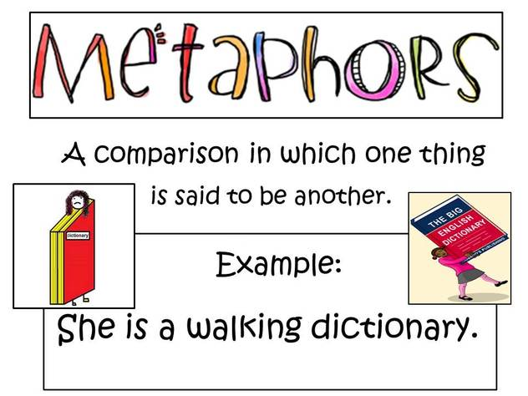

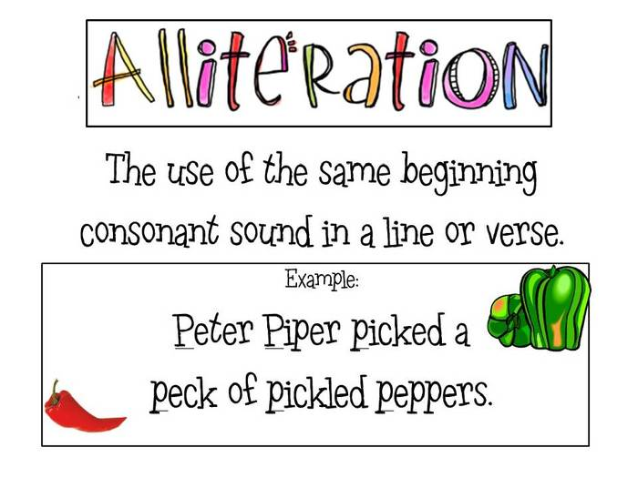
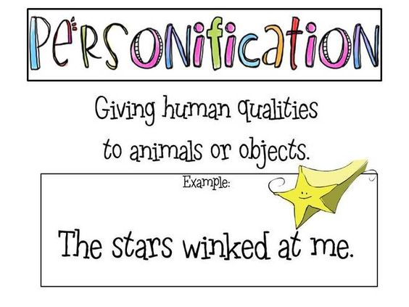

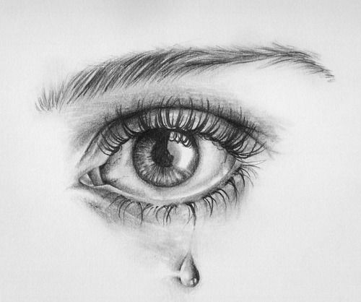
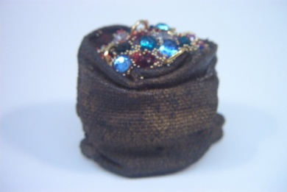
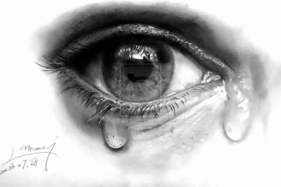
.

Question 1
Read the following extract from the story and answer the questions
The tears were jewels inside the darkness of the sack, clinking and chinking and winking. Tears of rage were red and glowed like rubies. Tears of envy or jealousy were green as emeralds. Tears of self-pity were turquoise. Scared tears were white like moonstones and guilty tears were amber.
1.1 Circle the correct answer in brackets.
“The tears were jewels inside the darkness of the sack...” (1)
is an example of (simile / metaphor / personification).
1.2 Find two examples of simile and write them down. (4)
___________________________________________________________________________________________________________________________________________________________________________________________________________________________________________________________________________________________________________________________________________________________________________________________________________________________________________________________________________________________________________________________________________________________________________________________________________________________
1.3 “Tears of rage were red and glowed like rubies”. (2)
In your opinion why does the author compare tears of rage with red rubies?
____________________________________________________________________________________________________________________________________________________________________________________________________________________________________________________________________________
1.4 Complete the sentence. (1)
The tears were _____________________ inside the darkness of the sack.
1.5 Circle the picture that best describes the tears in the extract. (1)




Question 2
Read the following account of the Narrator and answer the questions.
Narrator: The Tear Thief could tell that just one of these tears was worth a hundred cried over spilt milk or a thousand crocodile tears. She reached out her pale hand to pluck one from the girl's cheek. Just then the girl wiped her eyes with her sleeve and looked sadly into a puddle. The Tear Thief's mischievous face stared up at her.

2.1 Circle the letter of the correct answer (1)
What does the phrase “cried over spilt milk” mean?
A You should not cry over milk that has spilt on the floor.
B You should not get upset about something bad that has happened that you cannot change.
2.2 Circle the letter of the correct answer (1)
What does the phrase “crocodile tears” mean?
A To show sadness that is not sincere.
B To cry huge tears.
2.3 Why was this girl’s tears so precious? (1)
_________________________________________________________________________________________________________________________________________________________________________________________________________
2.4 Write down the word that describes the hand of the Tear Thief. (1)
“She reached out her pale hand to pluck one from the girl's cheek”.
___________________________________________________________________
2.5 Write down a word that means the same as “pluck”. (1)
___________________________________________________________________
2.6 Which word in this sentence describes the verb “looked”? (1)
“Just then the girl wiped her eyes with her sleeve and looked sadly into a puddle.”
___________________________________________________________________
Question 3
Read the following extract from The Tear Thief and answer the questions.
The Tear Thief jumped lightly from the top of the tree on to the roof of the first house. She crept along the rooftops, silent as smoke, listening, listening until she heard the crying again. ... Down the stairs, sly as steam, sneaked the Tear Thief, on to the landing and into the bathroom.

3.1 Down the stairs, sly as steam, sneaked the Tear Thief... (1)
What do we call the repetition of the ‘s’ sound in the underlined words above? Circle the correct answer in brackets.
(simile, alliteration, metaphor, assonance, homophones)
3.2 What do you think of the author’s choice of words, ‘silent as smoke’ and (1) ‘sly as steam’? How do they affect your image of the Tear Thief?
Complete the sentence: Choose from
honest sneaky
The author’s choice of words gives me the idea that the Tear Thief is a
________________________ person.
3.3 Circle the prepositions in the following sentence. (2)
She crept along the rooftops and down the stairs.
Question 4
Read the following extract from The Tear Thief and answer the questions.
The whole town moon-bathed as it slept. The river lay on its back and gazed at the moon, dazzled and lovesick.
4.1 What figure of speech is demonstrated in this extract? (1) Circle the letter of the correct answer.
A Metaphor
B Personification
c Simile
TOTAL: 20 ____
FORMAL ASSESSMENT TASK 1
ACTIVITY 4: LANGUAGE STRUCTURES AND CONVENTIONS
___________________________________________________________________
DATE:

Activity
Answer language questions based on a modern fairytale: The Tear Thief.

Form of assessment
Written presentation.

Assessment Tool:
Memorandum

Recording and Reporting

Criteria | Marks | Learner’s Achievement
Answer language questions based on the story. | 15

Comment

_________________________________________________________________________________________________________________________________________________________________________________________________________

What to do
Read the summary of the story “Tear Thief” and answer the language questions.

Have you heard about the tear thief? Every evening, she moves soundlessly about the town in her silk slippers, collecting children’s tears and popping them into her silvery waterproof sack. No-one can see her, because her reflection is only visible in puddles. Wherever she goes, she works a special magic, and the child she is visiting has no need to cry any more.
Question 1
1.1 Identify the proper nouns in the following sentence (2) and write it on the line.
A fairy visited Lerato in Springs yesterday evening.
___________________________________________________________________
1.2 Join the simple sentences with the conjunction in brackets to form (4) a complex sentence.
No-one can see her. Her reflection is only visible in puddles. (because)
____________________________________________________________________________________________________________________________________________________________________________________________________________________________________________________________________________
1.3 Read the extract and find the describing words. Match the describing word (adjective) to the noun that it describes.
Every evening, she moves soundlessly about the town in her silk slippers, collecting children’s tears and popping them into her silvery waterproof sack.
1.3.1 _______________________ slippers (1)
1.3.2 _____________________ _______________________ sack. (2)
1.4 Change the underlined singular nouns to plurals.
1.4.1 She collected tears for many day __________________ (1)
1.4.2 She popped the tears into two box _________________ (1)
1.4.3 All the baby _______________ stopped crying. (1)

1.5 Identify the compound word in the following sentence and write it down. (1)
The river lay on its back and gazed at the moon, dazzled and lovesick.
_________________________________________________________________
1.6 Fill in the missing possessive pronoun. (1)
The silk slippers on the bed belong to me. It is ______________
1.7 Write down a word next to the word in brackets that mean the opposite. (1)
(Down) ___________ the stairs, sly as steam, sneaked the Tear Thief.
TOTAL: (15)

FORMAL ASSESSMENT TASK 1
ACTIVITY 5: WRITING AND PRESENTING
___________________________________________________________________
DATE:

Activity
Write a story.

Form of assessment
Written presentation.

Assessment Tool:
Rubric

Recording and Reporting
Criteria | Marks | Learner’s Achievement
Content | 10
Planning | 10
Language | 10
Punctuation | 10
Structure | 10
TOTAL | 50÷2=25

Comment

_________________________________________________________________________________________________________________________________________________________________________________________________________

Rubric to assess essay writing
Criteria | LEVEL 7 | LEVEL 6 | LEVEL 5 | LEVEL 4 | LEVEL 3 | LEVEL 2 | LEVEL 1
MARKS: 50 | 10 – 8 | 7 | 6 | 5 | 4 | 3 | 2 – 0
Content | Paragraphs correctly copied and written in the correct order | Paragraphs copied with few mistakes in content and written in the correct order | Paragraphs copied with few mistakes in content and one mistake in the order of the paragraphs | Paragraphs copied with lots of mistakes and more than one mistake in the order of the paragraphs | Paragraphs copied with many mistakes in content and wrong order. | Poor transcription of paragraphs and totally in the wrong order | Poor transcription. Poor tempo  No order  Cannot read
Planning | Planning according to mind map have produced a well crafted and presentable essay. | Planning according to mind map have produced a presentable essay. | - Planning according to mind map have produced a reasonably good essay. | Planning according to mind map have produced a satisfactory, essay. | Planning according to mind map have produced a moderately presentable and coherent essay. | Inadequate despite mind map, Essay not well presented. | . Poorly presented essay.
Language | Critical awareness of impact of language.  Language, effectively used.  Uses highly appropriate language.  Choice of words exceptional, mature. | Critical awareness of impact of language.  Language, correct; able to use language effectively.  Choice of words varied and creative. | Critical awareness of language evident.  Language mostly correct.  Choice of words suited to text. | Some awareness of impact of language.  Language simplistic,  Choice of words adequate. | Limited critical language awareness.  Language mediocre, Flippant tone.  Choice of words basic. | Language and punctuation flawed.  Choice of words limited. | Language and punctuation seriously flawed.  Choice of words inappropriate.
Punctuation | Virtually error-free | Largely error-free. | Mostly error-free. | Still contains a few errors. | .Contains several errors. | Error-ridden. | No use of punctuation
Structure | Sentences, paragraphs well constructed.  Length in accordance with requirements of topic. | Sentences, paragraphs logical, varied.  Length correct. | Sentences, paragraphs well constructed.  Length correct. | Sentences, paragraphing might be faulty in places but essay still makes sense.  Length almost correct. | Sentences, paragraphs faulty but essay still makes sense.  Length - too long/short. | Sentences constructed at an elementary level.  Little to no paragraphs evident.  Length - too long/short. | Sentences muddled, inconsistent.  No use of paragraphing evident.  Length - far too long/short.
TOTALS

What to do
1. Write a narrative essay.
2. Use the following title for your essay: The Tear Thief
3. Use the mind map to help you.
4. Put the paragraphs in the correct order.

First she waits silently in a tree. Next she jumps on to the roof of the house. Then she creeps along the rooftop and listens.
Mind map

She hears the crying of a child. She sneaks down the stairs and into the bathroom. After that she plucks a teardrop from the boy’s cheek .

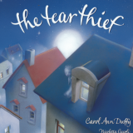

Wherever she goes she works a special magic and the child she visits has no need to cry any more.

Every evening the Tear Thief moves soundlessly about town in her silk slippers.
She collects children’s tears and pops them into her waterproof sack.
No-one can see her because her reflection is only visible in puddles.

TITLE
The Tear Thief

_____________________________________________________________________________________________________________________________________________________________________________________________________________________________________________________________________________________________________________________________________________________________________________________________________________________________________________________________________________________________________________________________________________________________________________________________________________________________________________________________________________________________________________________________________________________________________________________________________________________________________________________________________________________________________________________________________________________________________________________________________________________________________________________________________________________________________________________________________________________________________________________________________________________________________________________________________________________________________________________________________________________________________________________________________________________________________________________________________________________________________________________________________________________________________________________________________________________________________________________________________________________________________________________________________________________________________________________________________________________________________________________________________________________________________________________________________________________________________________________________________________________________________________________________________________________________________________________________________________________________
TOTAL: (25)
DATE:

Additional Writing Activity
Design and make a poster.

Form of assessment
Written presentation.

Assessment Tool:
Rubric

Recording and Reporting

CATEGORY | MARKS | ACHIEVEMENT
Required Elements | 5
Labels | 5
Graphics - Relevance | 5
Attractiveness | 5
Grammar | 5
Total | 25

Comment

_________________________________________________________________________________________________________________________________________________________________________________________________________

Rubric for assessing a poster
CATEGORY | 5 | 3 | 2 | 1
Required Elements  Content Design & Layout Graphics. | The poster includes all required elements as well as additional information. | All required elements are included on the poster. | All but 1 of the required elements are included on the poster. | Several required elements were missing.
Labels | All items of importance on the poster are clearly labelled with labels that can be read from at least 3 feet away. | Almost all items of importance on the poster are clearly labelled with labels that can be read from at least 3 feet away. | Many items of importance on the poster are clearly labelled with labels that can be read from at least 3 feet away. | Labels are too small to view OR no important items were labelled.
Graphics - Relevance | All graphics are related to the topic and make it easier to understand. | All graphics are related to the topic and most make it easier to understand. | All graphics relate to the topic. | Graphics do not relate to the topic
Attractiveness | The poster is exceptionally attractive in terms of design, layout, and neatness. | The poster is attractive in terms of design, layout, and neatness. | The poster is acceptably attractive though it may be a bit messy. | The poster is distractingly messy or very poorly designed. It is not attractive.
Grammar | There are no grammatical/mechanical mistakes on the poster. | There are 1-2 grammatical/mechanical mistakes on the poster. | There are 3-4 grammatical/mechanical mistakes on the poster. | There are more than 4 grammatical/mechanical mistakes on the poster

What to do
1. Design a poster.
2. Topic: The Tear Thief.
3. Theme: Tears.
4. Design a poster showing different reasons for crying.
Refer to the story, “The tear thief” and how emotions can be matched with jewels.
5. Check out the Rubric and pay attention to the criteria when designing your poster.
First Draft
________________________________________________________________________________________________________________________________________________________________________________________________________________________________________________________________________________________________________________________________________________________________________________________________________________________________________________________________________________________________________________________________________________________________________________________________________________________________________________________________________________________________________________________________________________________________________________________________________________________________________________________________________________________________________________________________________________________________________________________________________________________________________________________________________________________________________________________________________________________________________________________________________________________________________________________________________________________________________________________________________________________________________________________________________________________________________________________________________________________________________________________________________________________________________________________________________________________________________________________________________________________________________________________________________________________________________________________________________________________________________________________________________________________________________________________________________________________________________________________________________________________________________________________________________________________________________________________________________________________________________________________________________________________________
NAME: ____________________________________________ YEAR: _______
___________________________________________________________________

ENGLISH FAL
REVISION TEST
TERM 1
Have you learned anything this term?

Marks | 35 | 60
Learner achievement

Comment
_______________________________________________________________________________________________________________________________________________________________________________________________________________________________________________________________________________________________________________________________________________

Parent Signature

Question 1
Read the following extract from the story and answer the questions
The tears were jewels inside the darkness of the sack, clinking and chinking and winking. Tears of rage were red and glowed like rubies. Tears of envy or jealousy were green as emeralds. Tears of self-pity were turquoise. Scared tears were white like moonstones and guilty tears were amber.
1.1 Circle the correct answer in brackets.
“The tears were jewels inside the darkness of the sack...” (1)
is an example of (simile / metaphor / personification).
1.2 Find two examples of simile and write them down. (4)
___________________________________________________________________________________________________________________________________________________________________________________________________________________________________________________________________________________________________________________________________________________________________________________________________________________________________________________________________________________________________________________________________________________________________________________________________________________________
1.3 “Tears of rage were red and glowed like rubies”. (2)
In your opinion why does the author compare tears of rage with red rubies?
____________________________________________________________________________________________________________________________________________________________________________________________________________________________________________________________________________
1.4 Complete the sentence. (1)
The tears were _____________________ inside the darkness of the sack.
1.5 Circle the picture that best describes the tears in the extract. (1)

Question 2
Read the following account of the Narrator and answer the questions.
Narrator: The Tear Thief could tell that just one of these tears was worth a hundred cried over spilt milk or a thousand crocodile tears. She reached out her pale hand to pluck one from the girl's cheek. Just then the girl wiped her eyes with her sleeve and looked sadly into a puddle. The Tear Thief's mischievous face stared up at her.

2.1 Circle the letter of the correct answer (1)
What does the phrase “cried over spilt milk” mean?
A You should not cry over milk that has spilt on the floor.
B You should not get upset about something bad that has happened that you cannot change.
2.2 Circle the letter of the correct answer (1)
What does the phrase “crocodile tears” mean?
A To show sadness that is not sincere.
B To cry huge tears.
2.3 Why was this girl’s tears so precious? (1)
_________________________________________________________________________________________________________________________________________________________________________________________________________
2.4 Write down the word that describes the hand of the Tear Thief. (1)
“She reached out her pale hand to pluck one from the girl's cheek”.
___________________________________________________________________
2.5 Write down a word that means the same as “pluck”. (1)
___________________________________________________________________
2.6 Which word in this sentence describes the verb “looked”? (1)
“Just then the girl wiped her eyes with her sleeve and looked sadly into a puddle.”
___________________________________________________________________
Question 3
Read the following extract from The Tear Thief and answer the questions.
The Tear Thief jumped lightly from the top of the tree on to the roof of the first house. She crept along the rooftops, silent as smoke, listening, listening until she heard the crying again. ... Down the stairs, sly as steam, sneaked the Tear Thief, on to the landing and into the bathroom.

3.1 Down the stairs, sly as steam, sneaked the Tear Thief... (1)
What do we call the repetition of the ‘s’ sound in the underlined words above? Circle the correct answer in brackets.
(simile, alliteration, metaphor, assonance, homophones)
3.2 What do you think of the author’s choice of words, ‘silent as smoke’ and (1) ‘sly as steam’? How do they affect your image of the Tear Thief?
Complete the sentence: Choose from
honest sneaky
The author’s choice of words gives me the idea that the Tear Thief is a
________________________ person.
3.3 Circle the prepositions in the following sentence. (2)
She crept along the rooftops and down the stairs.
Question 4
Read the following extract from The Tear Thief and answer the questions.
The whole town moon-bathed as it slept. The river lay on its back and gazed at the moon, dazzled and lovesick.
4.1 What figure of speech is demonstrated in this extract? (1) Circle the letter of the correct answer.
A Metaphor
B Personification
c Simile
TOTAL: 20
Question 5 What to do
Read the summary of the story “Tear Thief” and answer the language questions.

Have you heard about the tear thief? Every evening, she moves soundlessly about the town in her silk slippers, collecting children’s tears and popping them into her silvery waterproof sack. No-one can see her, because her reflection is only visible in puddles. Wherever she goes, she works a special magic, and the child she is visiting has no need to cry any more.

1.1 Identify the proper nouns in the following sentence (2) and write it on the line.
A fairy visited Lerato in Springs yesterday evening.
___________________________________________________________________
1.2 Join the simple sentences with the conjunction in brackets to form (4) a complex sentence.
No-one can see her. Her reflection is only visible in puddles. (because)
____________________________________________________________________________________________________________________________________________________________________________________________________________________________________________________________________________
1.3 Read the extract and find the describing words. Match the describing word (adjective) to the noun that it describes.
Every evening, she moves soundlessly about the town in her silk slippers, collecting children’s tears and popping them into her silvery waterproof sack.
1.3.1 _______________________ slippers (1)
1.3.2 _____________________ _______________________ sack. (2)
1.4 Change the underlined singular nouns to plurals.
1.4.1 She collected tears for many day __________________ (1)
1.4.2 She popped the tears into two box _________________ (1)
1.4.3 All the baby _______________ stopped crying. (1)

1.5 Identify the compound word in the following sentence and write it down. (1)
The river lay on its back and gazed at the moon, dazzled and lovesick.
_________________________________________________________________
1.6 Fill in the missing possessive pronoun. (1)
The silk slippers on the bed belong to me. It is ______________
1.7 Write down a word next to the word in brackets that mean the opposite. (1)
(Down) ___________ the stairs, sly as steam, sneaked the Tear Thief.
TOTAL: (15)

Question 6 What to do
1. Write a narrative essay.
2. Use the following title for your essay: The Tear Thief
3. Use the mind map to help you.
4. Put the paragraphs in the correct order.

First she waits silently in a tree. Next she jumps on to the roof of the house. Then she creeps along the rooftop and listens.
Mind map

She hears the crying of a child. She sneaks down the stairs and into the bathroom. After that she plucks a teardrop from the boy’s cheek .

Wherever she goes she works a special magic and the child she visits has no need to cry any more.

Every evening the Tear Thief moves soundlessly about town in her silk slippers.
She collects children’s tears and pops them into her waterproof sack.
No-one can see her because her reflection is only visible in puddles.

TITLE
The Tear Thief

_____________________________________________________________________________________________________________________________________________________________________________________________________________________________________________________________________________________________________________________________________________________________________________________________________________________________________________________________________________________________________________________________________________________________________________________________________________________________________________________________________________________________________________________________________________________________________________________________________________________________________________________________________________________________________________________________________________________________________________________________________________________________________________________________________________________________________________________________________________________________________________________________________________________________________________________________________________________________________________________________________________________________________________________________________________________________________________________________________________________________________________________________________________________________________________________________________________________________________________________________________________________________________________________________________________________________________________________________________________________________________________________________________________________________________________________________________________________________________________________________________________________________________________________________________________________________________________________________________________________________
TOTAL: (25)

